16 May 2024

**To all MPs in England**

Dear Colleague,

**Draft relationships, sex and health education (RSHE) statutory guidance for schools**

I am writing to update you on the publication of the consultation on the draft revised RSHE statutory guidance.

As you know, good RSHE plays a fundamental role in equipping young people with the knowledge needed to make informed decisions about their wellbeing, health and relationships, setting them up for future success. It enables children to be taught content in a safe and controlled environment by a trusted adult.

This the first review of the RSHE curriculum since it came into force in September 2020. The Prime Minister and I brought it forward in response to disturbing reports that inappropriate material is being used to teach RSHE in some schools. We have listened to colleagues across government, gathered evidence from stakeholders and considered advice from the independent expert panel who advised me on the application of suitable age limits for certain topics. This will ensure that concepts are not introduced before children are old enough to understand them, and that lessons do not prompt them to explore things they are not ready for. Children must be allowed to be children.

The draft guidance takes a clear parent-centred approach and will ensure that teaching has the best interests of children at heart. In revising the guidance, we have taken the opportunity to make it clearer and more accessible to the schools and teachers who use it.

The key substantial changes are:

* Making clear that gender identity is a contested subject which should not be taught.
* Sex education will not be taught before Year 5, and at that point from a purely scientific standpoint.
* A new section that prioritises transparency with parents and clarifies how there is scope within the current law to share classroom materials with parents – making sure parents know what their children are being taught in RSHE. It also explains how schools should not agree to any contractual restrictions on showing parents this content.
* Following reports of schools seeing rising levels of harmful misogynistic behaviour, the guidance now includes a dedicated section on sexual harassment and sexual violence, covering specific types of abusive behaviour which were not explicitly discussed previously, such as stalking, well as advice for teachers about how to address misogynistic online influencers.
* We have included an additional topic in both the primary and secondary curriculum on personal safety. This includes understanding the dangers of fire, roads, railways and water.
* After meeting bereaved families, experts and teachers to explore how suicide prevention could be taught as part of RSHE, we have added content to the guidance, which sets out the options for how schools might address this, either directly or indirectly as they feel will best suit their pupils and according to the confidence and expertise of staff to teach it safely. We have not, however, made it a requirement for schools to teach directly about suicide, as schools need to consider whether their teachers have confidence and expertise to teach it safely.

As this is a devolved matter, the Department for Education will implement these proposals in England only. Scotland, Wales and Northern Ireland have different policies in place and my department will continue to engage with each of the Devolved Administrations to encourage a joined-up approach on this matter.

I encourage you and your constituents to respond to the public consultation that is now available on [GOV.UK](https://www.gov.uk/government/consultations/review-of-the-rshe-statutory-guidance) and will close on 11th July.

Yours Sincerely,

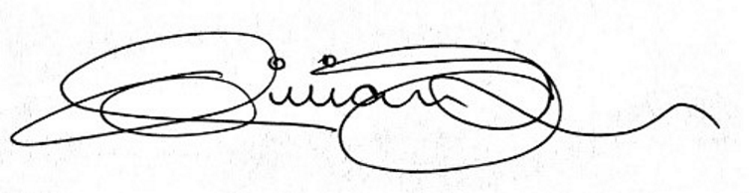

**The Rt Hon Gillian Keegan MP**

**Secretary of State for Education**